FDA Project

Release 2 – DQ to Govern Scoring

Test Summary Report (TSR)

Prepared By Infogix Professional Services

January 2, 2020

Table of Contents

Change Log 3

**1** Introduction 4

**2** **Project Scope** 5

**3** **Different Sprints** 6

**4** **Executive Summary** 7

4.1 Deviation between Test Plan and the Test scope: 7

**5** **Test execution Summary** 8

5.1 AT Testing Scope 8

5.2 Test Case Summary 8

5.3 Defect Summary 8

5.4 Test Execution summary : 9

5.4.1 Test Cases 9

5.4.2 Test Exclusions 9

5.4.3 Failed Test Cases 9

5.4.4 Risks 9

5.4.5 Test Schedule 10

**6** **Outstanding Defects** 11

**7** **Exit Criteria and Conclusion** 12

7.1 Exit Criteria 12

7.2 Conclusion 12

**8** **Sign-Off** 13

**9** **Reference Document(s)/ Links** 14

**10** **Document Control Sheet** 15

# Change Log

| Date | Ver. | Changes | Modified by |
| --- | --- | --- | --- |
| Jan 3, 2020 | 1.0 | Baselined | Jagadish Sankar |
|  |  |  |  |
|  |  |  |  |
|  |  |  |  |

# Introduction

This document is the Test Summary Report (TSR) for **FDA Project – Release 2 - DQ to Govern Scoring**. This document is published on completion of Application Testing (AT) phase with details relating to that particular phase. Its purpose is to answer the following questions:

* What was tested?
* What are the results?
* What are the outstanding defects/Issues?
* What are the conclusions and assessment of risk?

AT Phase is covered with three cycles.

|  |  |
| --- | --- |
| **Test Cycles** | **Scope of Test Cycle** |
| AT – Cycle 1 | All test cases part of delivered functional scope of particular sprint for testing. |
| AT – Cycle 2 | Bug fixes verification + Regression of AT – Cycle 1. |
| AT – Cycle 3 | Combined Integration testing of all sprints with Consolidated build. This cycle is applicable for project(s) where there is a need of integration testing. |

# **Project Scope**

|  |  |  |  |
| --- | --- | --- | --- |
| **S.No.** | **Project Code** | **Project** | **Summary** |
| 1 | S-Field Developed Assets | Release 2 - DQ+ to Govern Scoring | Release 2 enhancements in DQ Scoring Framework comprises of:   * Identifying change in Metamodel Structure and version, E2E Process Scheduling * Standardizing Regex based Rule List, populating attribute value in Detail record while evaluating rule, and * Improvements in Score Refreshing module to handle error in posting |

# **Different Sprints**

FDA Project are divided into multiple sprints. This AT test summary report document covers all the sprints.

|  |  |  |  |  |
| --- | --- | --- | --- | --- |
| **S.No** | **FDA Project** | **Sprints** | **Start Date** | **End Date** |
| 1 | Release 2 - DQ+ to Govern Scoring | Sprint 6 | 12th Nov 2019 | 2nd Jan 2020 |
| Sprint 7 |
| Sprint 8 |
| Sprint 9 |

# **Executive Summary**

1. Core functionality of project as per technical design document are covered in AT successfully.
2. Test execution conducted on Cafedev – Govern and Cafe-model – DQ+ environment by creating separate environment for testing.
3. Below project is executed successfully as per the project plan with multiple test cycles, also tested with combined sprint integration testing with consolidated release.

* Release 2 - DQ+ to Govern Scoring

1. Overall 42 test cases created for this FDA project, 100% test cases were executed with 100% passed rate.
2. Total 32 defects were found. Refer to the Section 5.3 for defect summary.

## Deviation between Test Plan and the Test scope:

N/A

# **Test execution Summary**

The test summary in this section covers all sprints test execution of following FDA project.

* Release 2 - DQ+ to Govern Scoring

## AT Testing Scope

The objective of this test is to ensure that each element of the solution meets the functional requirements of the framework as outlined in the Technical Design Document.

## Test Case Summary

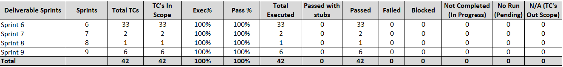

## Defect Summary

**Overall: (All Stages)**

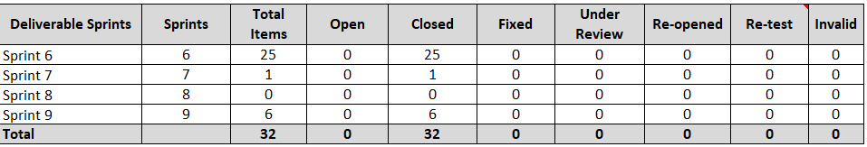

*Test and Defect Summary details provided are based on status as of 02-Jan-2020.*

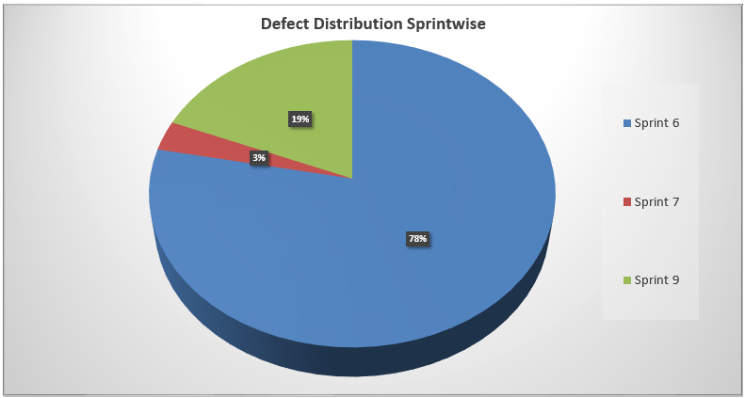

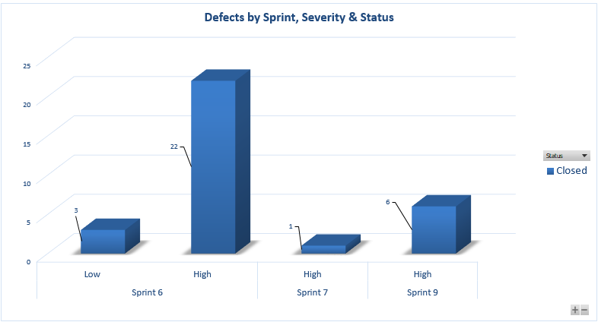

## Test Execution summary :

### Test Cases

Test case details are present in the attached document.



### Test Exclusions

N/A

### Failed Test Cases

N/A

### Risks

|  |  |  |  |
| --- | --- | --- | --- |
| **Risk ID** | **Risk Description** | **Mitigation Plan** | **Status** |
| **1** | For deployment and execution, configuration in Govern is accurate. | User manual is created with the detail steps to create the configuration in the Govern. | Closed |
| **2** | Below are the sample source are created for E2E testing. Customization is required for new source to consider.  CMF  CMF_EXT_DATA  CUST_ID_ACCT_MAP | Customization of read data source process is required. | Closed |

### Test Schedule

| Testing Type | Planned Test Schedule | | | Actual Test Schedule | | |
| --- | --- | --- | --- | --- | --- | --- |
| **Start Date** | **End Date** | **Start Date** | | **End Date** |
| Application Testing | 12th Nov 2019 | 31st Dec 2019 | 12th Nov 2019 | | 2nd Jan 2020 |

# **Outstanding Defects**

The table below contains details of any Incidents/Issues which do not have plan in place to correct them in this release.

Outstanding Incident/Issues: **No outstanding defects in Release 2**

| Incident / Issue No. | Project | Description of the Incident/Issue | Severity(H, M, L) | Defect Status |
| --- | --- | --- | --- | --- |
|  |  |  |  |  |

# **Exit Criteria and Conclusion**

## Exit Criteria

|  |  |  |
| --- | --- | --- |
| **S.No.** | **Criteria** | **Met/Not Met** |
| 1 | All planned test cases have been successfully executed. | Met |
| 2 | All defects found have been recorded in the Test Cases attached in the section 5.4.1. | Met |
| 3 | There is no Outstanding defects open with severity High/Medium. | Met |
| 4 | Test Summary Report (this document) issued to stakeholders | Met |

## Conclusion

Based on Exit Criteria, recommending to promote following FDA project in any project implementation.

* Release 2 - DQ+ to Govern Scoring

# **Sign-Off**

The completion of the sign-off page is a testament by the signatories below that the following has been achieved or agreed:

* The document has been peer reviewed and all defects have been fixed
* The document is complete and accurate
* This document will be placed under configuration control

|  |  |
| --- | --- |
| Reviewed Revision Number | 0.1 |
| Baseline Revision Number | 0.1 |
| Baseline Date | 3-Jan-2020 |
| Author | Jagadish Sankar |

|  |  |  |  |
| --- | --- | --- | --- |
| Organisational Position | Project Manager | | |
| Signature |  | Date | 3-Jan-2020 |
| Name | Prasanna Balaraman | Contact Number | +91 9916911757 |

# **Reference Document(s)/ Links**

| **S. No.** | **Document** | **Links** |
| --- | --- | --- |
| 1 | DQ+ to Govern Scoring | TechnicalDesign - DQ_Gov_Scoring_v0.21.docx |

# **Document Control Sheet**

The purpose of this section is to capture all changes made to the content of the document.

Contact for Enquiries and Proposed Changes

If you have any questions regarding this document, please contact:

|  |  |
| --- | --- |
| Name | Jagadish Sankar |
| Designation | Test Manager |
| Phone | +91 9999015034 |
| Email Address | [jsankar@infogix.com](mailto:jsankar@infogix.com) |